SCHOOL

Trial WACE Examination, 2011

Question/Answer Booklet

MATHEMATICS 3C/3D
SOLUTIONS

Section Two:

Calculator-assumed

Student Number: In figures

In words

Your name

Time allowed for this section
Reading time before commencing work: ten minutes
Working time for this section: one hundred minutes

Materials required/recommended for this section

To be provided by the supervisor
This Question/Answer Booklet
Formula Sheet (retained from Section One)

To be provided by the candidate
Standard items: pens, pencils, pencil sharpener, eraser, correction fluid/tape, ruler, highlighters

Special items: drawing instruments, templates, notes on two unfolded sheets of A4 paper, and up to three calculators satisfying the conditions set by the Curriculum Council for this examination.

Important note to candidates

No other items may be used in this section of the examination. It is your responsibility to ensure that you do not have any unauthorised notes or other items of a non-personal nature in the examination room. If you have any unauthorised material with you, hand it to the supervisor before reading any further.

Structure of this paper

Section | Number of questions available | Number of questions to be answered | Working time (minutes) | Marks available | Percentage of exam
Section One:  Calculator-free | 8 | 8 | 50 | 40 | 33
Section Two:  Calculator-assumed | 12 | 12 | 100 | 80 | 67
 |  |  | Total | 120 | 100

Instructions to candidates

- The rules for the conduct of Western Australian external examinations are detailed in the Year 12 Information Handbook 2011. Sitting this examination implies that you agree to abide by these rules.

- Write your answers in the spaces provided in this Question/Answer Booklet. Spare pages are included at the end of this booklet. They can be used for planning your responses and/or as additional space if required to continue an answer.
- Planning: If you use the spare pages for planning, indicate this clearly at the top of the page.
- Continuing an answer: If you need to use the space to continue an answer, indicate in the original answer space where the answer is continued, i.e. give the page number. Fill in the number of the question(s) that you are continuing to answer at the top of the page.

- Show all your working clearly. Your working should be in sufficient detail to allow your answers to be checked readily and for marks to be awarded for reasoning. Incorrect answers given without supporting reasoning cannot be allocated any marks. For any question or part question worth more than two marks, valid working or justification is required to receive full marks. If you repeat an answer to any question, ensure that you cancel the answer you do not wish to have marked.

- It is recommended that you do not use pencil, except in diagrams.

Section Two: Calculator-assumed (80 Marks)
This section has twelve (12) questions. Answer all questions. Write your answers in the spaces provided.

Working time for this section is 100 minutes.

Question 9 (5 marks)
In a production facility, the lengths of metal rods are recorded to the nearest 5 mm. The rounding error, 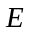 mm, is the difference of the actual rod length minus the rounded length and is uniformly distributed between -2.5 mm and 2.5 mm.

(a) State the probability density function for . (2 marks)
✓
✓
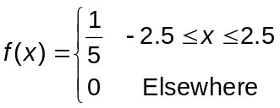

(b) Determine

(i) 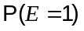 (1 mark)
✓

(ii) 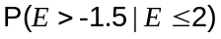 (1 mark)
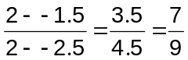
✓

(c) What is the probability that a randomly chosen rod with a recorded length of 135 mm has a real length of a least 136 mm? (1 mark)
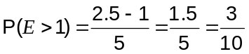
✓

Question 10 (6 marks)
From an analysis of the median house price (M) in a city on July 1 each year from 1980 until 2010, it was observed that 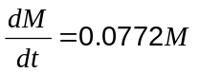, where is the time in years since July 1 1980.

(a) According to this model, how long did it take for house prices to double? (2 marks)

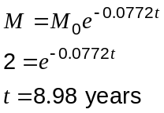
✓

✓

It was also observed that the median house price was $440 000 in 2008.

(b) What was the instantaneous rate of change of the median house price at this time?
(1 mark)

✓

(c) What was the median house price in 1988, to the nearest thousand dollars? (2 marks)

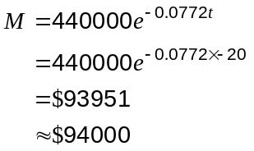
✓

✓

(d) What was the average rate of change of the median house price between 1988 and 2008?
(1 mark)
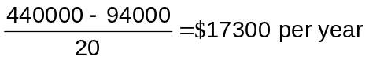
✓

Question 11 (6 marks)
Oil is poured onto the surface of a large tank of water at a rate of 0.7 cm³ per second. It spreads out on the surface to form a circular slick of uniform thickness 1.5 mm which can be modelled by a thin cylindrical shape.

(a) At what rate is the radius of the slick increasing one minute after pouring began?
(4 marks)

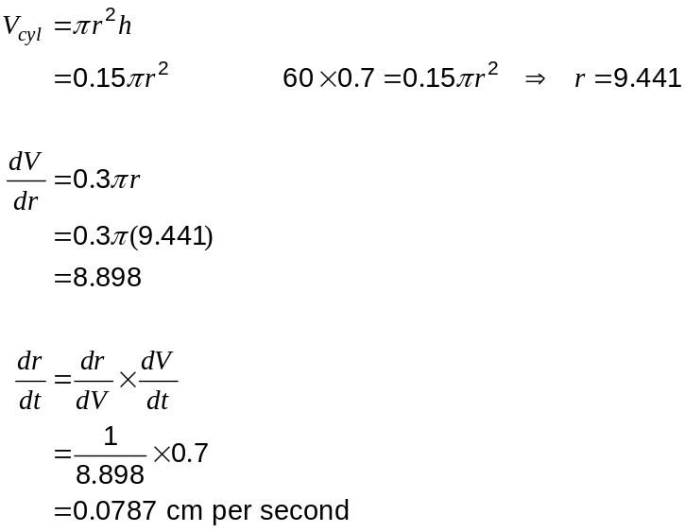
✓

✓

✓

✓

(b) Use the incremental formula 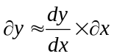 to estimate the time the slick will take to increase in radius from 55 cm to 55.5 cm. (2 marks)

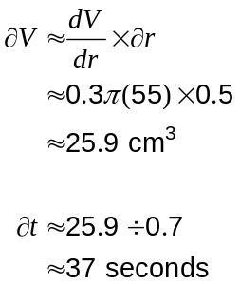

✓

✓

Question 12 (7 marks)
A drink company make a fresh fruit drink every day using a combination of apples and pears. The recipe requires that the weight of apples must be no more than twice that of pears and at the same time the weight of the pears together with twice the weight of apples must be at least 160kg. Daily supplies are limited to 100kg of apples and 90kg of pears.

With representing the weight of apples used and the weight of pears, the feasible region for this information is shown on the graph below.
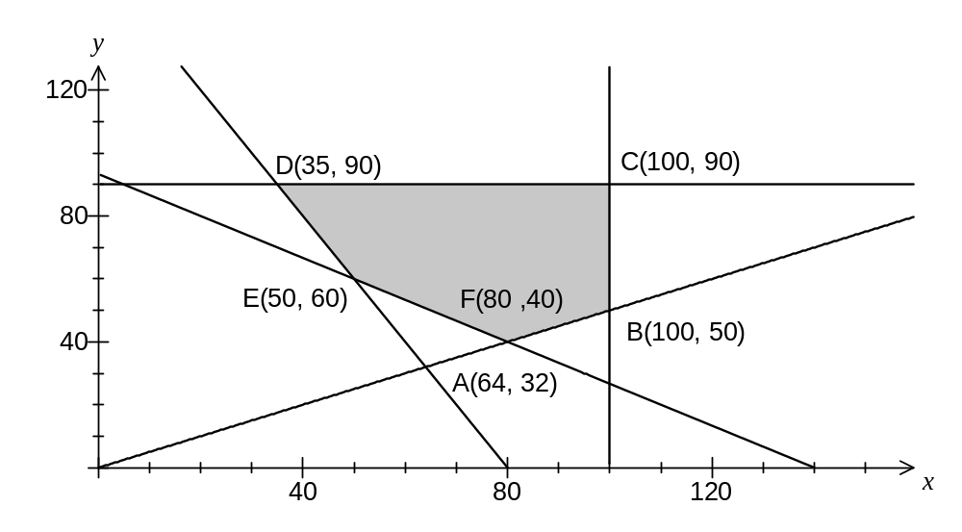
✓
✓
✓

From a practical point of view, the company have another constraint such that twice the weight of the apples added to three times the weight of pears must be at least 280kg.

(a) Add this fifth constraint to the graph above and clearly label the vertices of the new feasible region. (3 marks)
Add 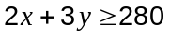.

Intersects with 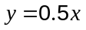 at (84, 40)

Intersects with 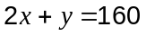 at (50, 60)
✓
✓

✓

(b) If the price of apples is $1.80 per kg and pears $2.20 per kg, find the minimum daily cost of fruit whilst satisfying all the above constraints. (2 marks)
D(35, 90) cost is $261
E(50, 60) cost is $222
F(80, 40) cost is $232

Minimum cost is $222.
✓

(c) Consider the situation where the price of apples fell to $1.70 per kg but the price of pears fell considerably more. Given that the vertex in part (b) still yielded the minimum cost, what would be the minimum price of pears on this day? (2 marks)

Cost will be equal at both D and E.

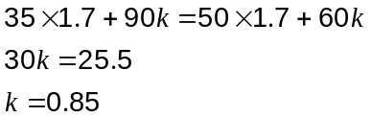

Minimum price will be $0.85

✓

✓
Question 13 (5 marks)
Two functions are defined by 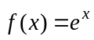 and 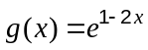.

(a) Describe, in order, the transformations which must be applied to the graph of to obtain the graph of 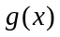. (2 marks)

1. Translate 1 unit to the left

2. Reflect in the y-axis and dilate horizontally by a scale factor of 1/2.

✓

✓

(b) Determine the domain and range of 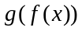. (3 marks)

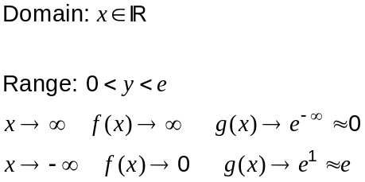
✓

✓
✓

Question 14 (5 marks)
A cubical six-sided dice is known to be biased. It is thrown 3 times and the number of sixes is noted. This experiment is then repeated 200 times in all and the results are shown in the table.

Number of sixes | 0 | 1 | 2 | 3
Frequency | 67 | 93 | 33 | 7

(a) What is the mean number of sixes? (1 mark)
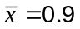
✓

(b) What is the probability of obtaining a six when this dice is thrown? (1 mark)
If 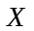 is the random variable 'number of sixes in 3 throws of the dice', then assume that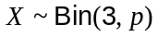. 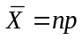 and so 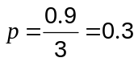
✓

(c) Use a suitable binomial distribution to calculate the theoretical frequency distribution for the number of sixes in 200 such experiments and comment on how well your distribution models the experimental results above. (3 marks)

If 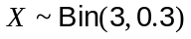 then

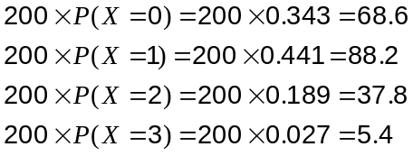

The experimental and theoretical frequencies are very close to each other, suggesting that the use of the binomial model is appropriate.

✓

✓

✓

Question 15 (8 marks)
(a) A team of 3 students is chosen at random from a group of 4 girls and 5 boys for a TV game show. What is the probability that the team chosen consists of more boys than girls?
(2 marks)
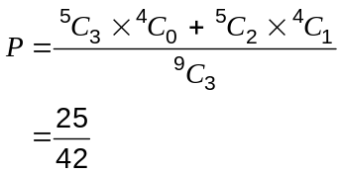
✓

✓

(b) In one of the games, the team choose one of four closed doors. The doors then open to reveal a prize placed at random behind just one of them. The team keep the prize if they are correct. How many rounds of this game must the team play so that the probability of them obtaining at least one prize is greater than 0.95? (3 marks)
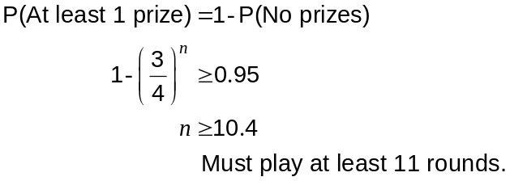

✓

✓

✓

(c) At the close of the show, the team can select one of two boxes to keep as another prize. Inside each of the boxes are five sealed envelopes, each containing a voucher. In one of the boxes, four of the vouchers are worth $10 000 and the fifth $100, whilst in the other box two of the vouchers are worth $10 000 and the other three, $100 each.

The team is allowed to choose an envelope from one of the boxes and open it. They must then decide whether to keep that box or choose the other one. The team plan to keep the box that the envelope they opened came from if it contains a $10 000 voucher. Otherwise they will take the other box.

What is the probability that the team wins more than $30 000? (3 marks)
Let event A be choose box with four $10 000 vouchers and event V be open envelope with a $10 000 voucher inside. We need 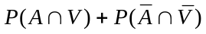.
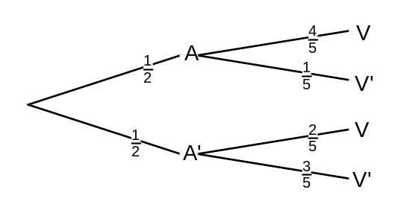
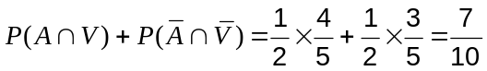

✓
✓
✓
Question 16 (7 marks)
The velocity 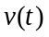 ms⁻¹ of a body moving along a straight track after seconds, is given by
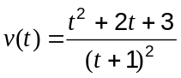, 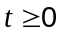.

(a) Find the acceleration of the body after 4 seconds. (1 mark)
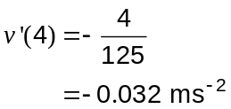

(b) Explain why the body is never stationary over the given domain. (1 mark)

The numerator of has no real roots and so the velocity of the body can never be 0.
✓

(c) If 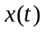 m is the displacement of the body from a fixed point on the track and 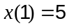 determine 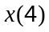. (2 marks)
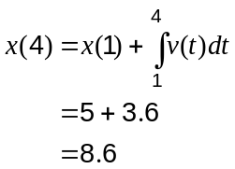
✓

✓

(d) The average speed of the body over the first seconds is 1.2 ms⁻¹. Determine the value of . (3 marks)
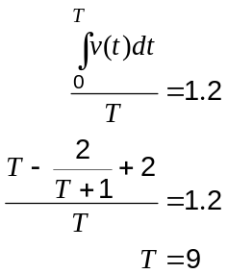

✓

✓
✓
Question 17 (11 marks)
A bottling machine fills bottles of water. The content, X mL, of the bottles is a normally distributed random variable with a mean of 391 mL and a standard deviation of 8.15 mL.

It is known that 1 out of every 200 bottles that the machine fills has less than the stated contents on the bottle label.

24 bottles are packed in a carton and 48 cartons are loaded onto a shipping pallet.

(a) What is the probability that a bottle contains more than 375 mL of water? (1 mark)
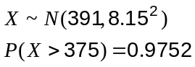

✓

(b) What are the stated contents on the bottle label? (2 marks)
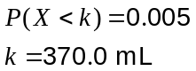
✓

✓

(c) What is the probability that a carton does not contain any bottles with less than the stated contents? (2 marks)
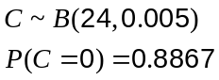
✓

✓

(d) What is the probability that a pallet contains at least one bottle with less than the stated contents? (2 marks)
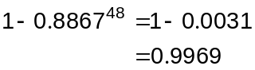

✓
✓

(e) The bottling company randomly choose a pallet from the stockyard. The mean content of all the bottles from this pallet is 389.9 mL.

(i) Construct a 90% confidence interval for the mean content of all bottles. (3 marks)

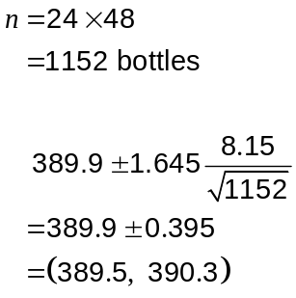

✓
✓

✓

(ii) Should the interval be of concern to the bottling company? (1 mark)
Yes. The interval does not come close to containing the accepted plant mean of 391 and so under filling may be commonplace.

✓
Question 18 (5 marks)
The diagonals AC and BD of a quadrilateral ABCD intersect at O.

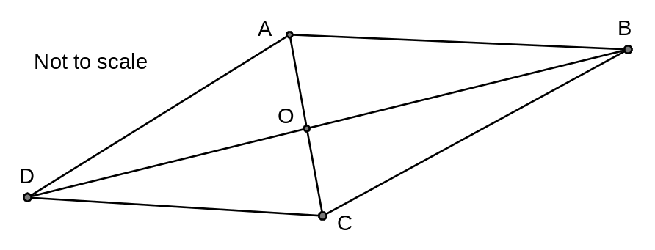

If OA = 3 cm, OB = 15 cm, AC = 8 cm and BD = 24 cm, prove that AD is parallel to BC.

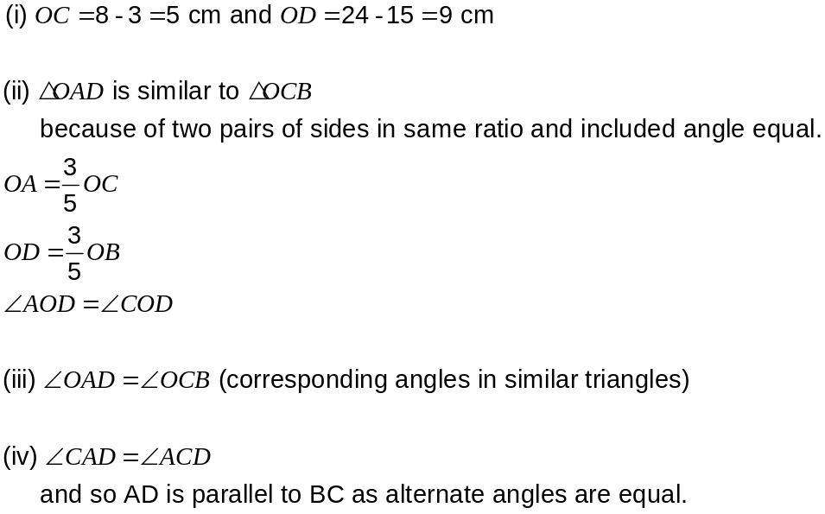

✓

✓

✓
✓
✓
Question 19 (8 marks)
A function has derivative given by 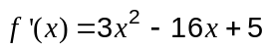.

Another function 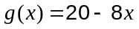 is a tangent to in the first quadrant.

Sketch the curves and , showing the exact coordinates of all axis-intercepts, turning points and points of inflection.
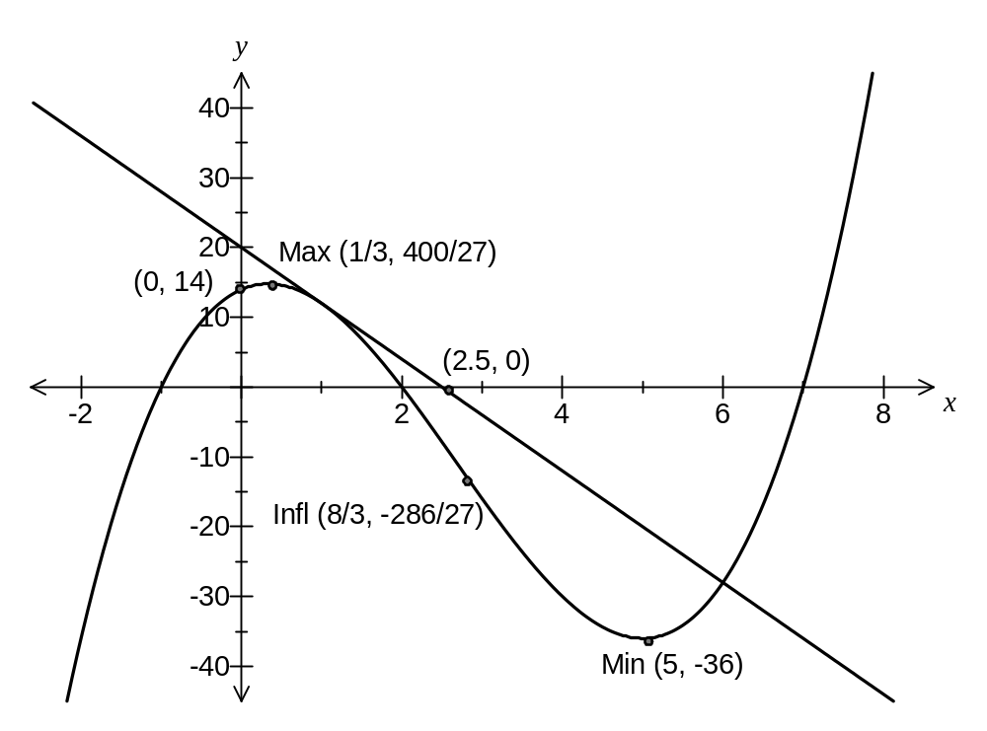
✓
✓✓
Intercepts ✓
inflection✓✓
max ✓
min✓
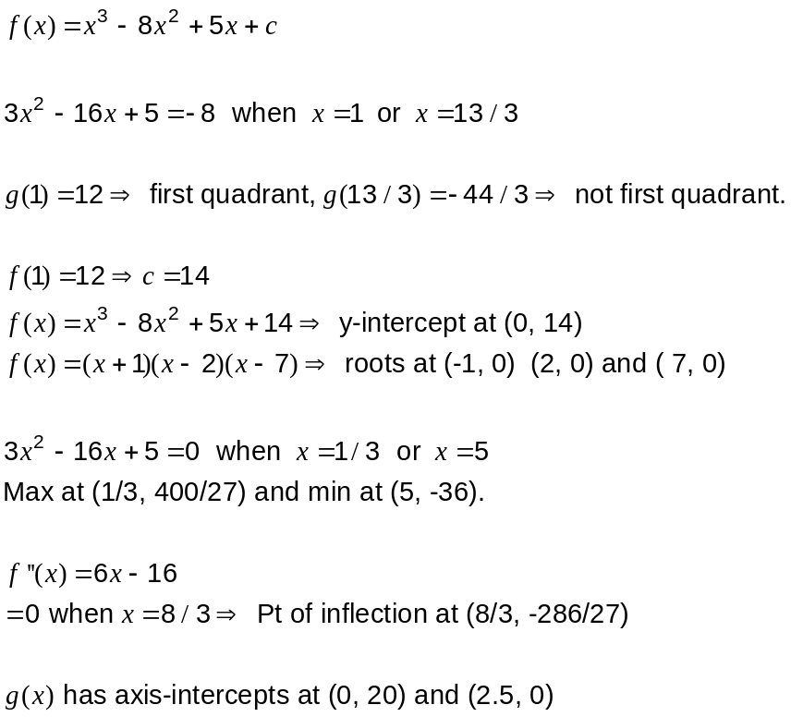

Question 20 (7 marks)
A teacher introduced the following probability experiment to her class. Five cards with the letters A, B, C, D and E are thoroughly shuffled and then the letter on the top card noted. This trial is repeated a total of 20 times to complete the experiment.
Let be the random variable 'the number of times the card with the letter A is drawn in one experiment'.

(a) Explain why is a discrete random variable, and state the parameters of the binomial distribution which follows. (2 marks)
X is a drv because:
it can only take specific integer values
the associated probability distribution sums to 1

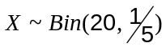
✓

✓

(b) Find 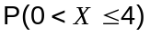. (1 mark)
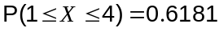
✓

(c) A large number of students each carry out the experiment above times and then they share with their class the mean of their experiments, 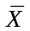. If approximately 90% of the means of the students' experiments are less than 4.354, use the central limit theorem to estimate . (4 marks)
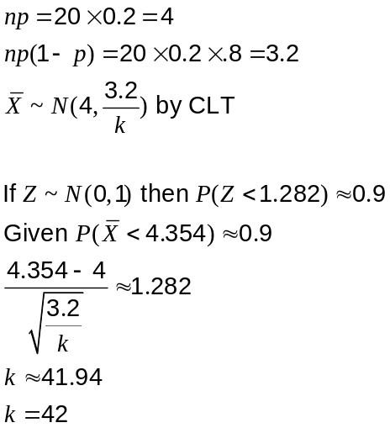

✓

✓
✓
✓
Additional working space

Question number: _________

Additional working space

Question number: _________

Additional working space

Question number: _________

This examination paper may be freely copied, or communicated on an intranet, for non-commercial purposes within educational institutes that have purchased the paper from WA Examination Papers provided that WA Examination Papers is acknowledged as the copyright owner. Teachers within purchasing schools may change the paper provided that WA Examination Paper's moral rights are not infringed.

Copying or communication for any other purposes can only be done within the terms of the Copyright Act or with prior written permission of WA Examination papers.

Published by WA Examination Papers
PO Box 445 Claremont WA 6910

